
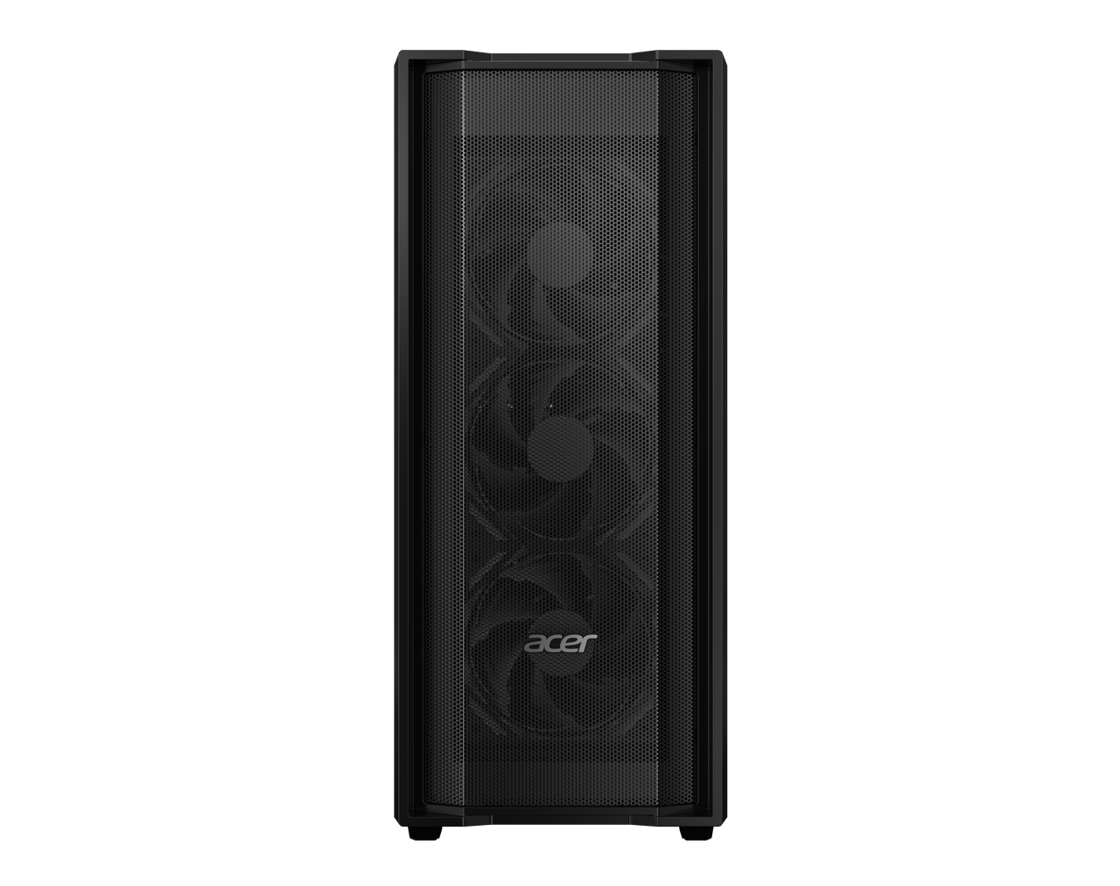

Acer Veriton 8000 Large Tower Workstation

SA

 |  | SPECIFICATIONS |  |  | Acer Veriton 8000 |  |  |  | VK8735G
 |  | 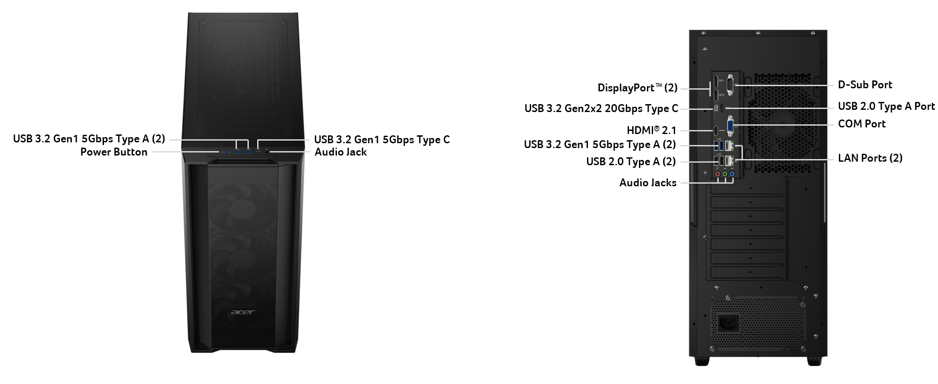
 |  | Operating System |  | Windows 11 Home 64-bit | Windows 11 Pro 64-bit | UEFI Shell
 |  | CPU and Chipset |  | Intel® Core™ Ultra 9 processor 285, Intel® Graphics |  | Intel® Core™ Ultra 7 processor 265, Intel® Graphics |  | Intel® Core™ Ultra 5 processor 225, Intel® Graphics |  |  | Chipset:  Intel® W880
 |  | Memory |  | 32 / 16 / 8 GB DDR5 6400 MT/s CUDIMM  32 / 16 / 8GB DDR5 5600 MT/s UDIMM
 |  | Graphics |  | NVIDIA® GeForce RTX™ 5090  NVIDIA® GeForce RTX™ 5080 |  | NVIDIA® GeForce RTX™ 5070  NVIDIA® GeForce RTX™ 5060 |  | NVIDIA® RTX™ A1000  NVIDIA® RTX™ A400
 |  | Audio |  | Integrated high-definition audio | 5.1-channel surround sound
 |  | Storage |  | HDD:  2 TB | 3.5-inch | 7200 RPM |  |  | Performance SSD:  1024 GB / 2048 GB | M.2 2280 | PCIe Gen 4 |  |  | SSD:  512 GB / 1024 GB | M.2 2280 | PCIe Gen 4
 |  | Wireless and Networking |  | Wi-Fi 7 | 802.11be/ax/ac/a/b/g/n | Bluetooth® 5.4  Wi-Fi 6E | 802.11ax/ac/a/b/g/n | Bluetooth® 5.3
 |  | Expansion Slot(s) |  | 2 x PCIe x16 slots |  | 2 x PCIe x1 slots |  | 2 x M.2 slots for SSD |  |  | 1 x M.2 slot for WLAN
 |  | Commercial Features |  | Security:  TPM v2.0 | Trusted Platform Module  Hard drive password protection via BIOS |  | Manageability:  Intel® vPro™ technology  Wake on LAN |  | Storage Management:  RAID support via BIOS |  |  | Selected Option:  Internal Speaker
 |  | Dimensions and Weight |  | 209.8 (W) x 461.7 (D) x 495 (H) mm (8.26 x 18.18 x 19.49 inches)
 |  | Power Supply |  | 1000 W PFC, auto-sensing, 80PLUS Gold, ATX  ​850 W PFC, 80PLUS® Gold, ATX  650 W, 80 PLUS® Gold
 |  | System Compliance and Certification |  | Compliance  EPEAT Silver® design | EPEAT registration varies by country  ENERGY STAR® | GS | DMI | PC2001 |  |  |  | Certification:  EPEAT Silver | BSMI | CE | FCC | CB
 |  | Options and Accessories |  | Wireless (2.4 GHz RF) keyboard and mouse  USB keyboard and mouse
 |  | Warranty |  | One-year International Travelers Warranty (ITW)
 |  | Disclaimers
 |  | • | Specifications vary depending on model.
 |  | • | 64-bit software is required to enjoy the advantages of 64-bit processing.
 |  | • | A 64-bit operating system is required to enjoy the ultimate performance of 4 GB or higher memory.
 |  | • | Memory speed may vary, depending on the CPU, chipset or memory fitted.
 |  | • | 1 GB is 1 billion bytes. Actual formatted capacity is less and may vary depending on preloaded materials and operating environment. Recovery Management uses a portion of the stated hard disk capacity as dedicated backup space.
 |  | • | Total available graphics memory comprises dedicated video memory, system memory, and shared system memory. This figure will vary depending on system memory, installed drivers, BIOS settings and other factors.
 |  | • | Intel® vPro™ technology is sophisticated and requires setup and activation. Availability of features and results will depend upon the setup and configuration of your hardware, software, and IT environment. To learn more visit Intel website.
 |  | • | EPEAT® registration varies by country and configuration. See http://www.epeat.net/ for registration status for each country.
 | Product Sheet is based on Veriton K8735G Specifications (v2-0-0) (Preview)
In a continuing effort to improve the quality of our products, information in this document is subject to change without notice. Images shown are only representations of some of the configurations available for this model. Availability may vary depending on region.
As a phenomenon known to thin-film transistors (TFTs), liquid crystal displays (LCDs) commonly exhibit a small number of discoloration dots, as so-called "non-conforming pixels." This phenomenon is a limitation of TFT LCD technology, not a product defect, and as such is not covered by Acer's warranty.
© 2026. All rights reserved.
Microsoft and Windows are registered trademarks of Microsoft Corporation.
3D XPoint, Agilex, Altera, Arc, Arria, Avalon, Axxia, Barefoot Networks, the Barefoot logo, the Footsie logo, Celeron, Cyclone, Docea, DoubleShot, eASIC, easicopy, FlexRAN, Gaudi, Granulate, Hyperflex, Intel, the Intel logo, Intel Adaptix, Intel Agilex, Intel Atom, Intel CoFluent, Intel Core, Intel Evo, Intel Geti, Intel Inside, the Intel Inside logo, Intel Optane, Intel RealSense, Intel SpeedStep, Intel Tiber, Intel Unison, Intel vPro, Iris, Killer, Linutronix, MAX, Movidius, Myriad, Nios, OmniBridge, OpenVINO, the OpenVINO logo, Pentium, Quartus, Simics, SmartByte, SoftSilicon, Sound Mark, StarPro, Stay With It, the Engineering Stay With It logo, Stratix, the Stratix logo, The Journey Inside, Thunderbolt, the Thunderbolt logo, Tofino, Ultrabook, VTune, and Xeon are trademarks of Intel Corporation or its subsidiaries.

About Acer
Founded in 1976, Acer is one of the world's top ICT companies with a presence in more than 160 countries. As Acer evolves with the industry and changing lifestyles, it is focused on enabling a world where hardware, software and services will fuse with one another, creating ecosystems and opening up new possibilities for consumers and businesses alike. Acer's 7,500 employees are dedicated to the research, design, marketing, sale, and support of products and solutions that break barriers between people and technology. Please visit www.acer.com for more information.

